随着消息处理的深入，消息类型逐步增多，但可以试着从不同的角度进行总结、比对，把握主要脉络。

比如，鼠标消息、键盘消息、快捷键消息等等。

基本消息
如WM_CREATE, WM_CLOSE, WM_DESTROY。

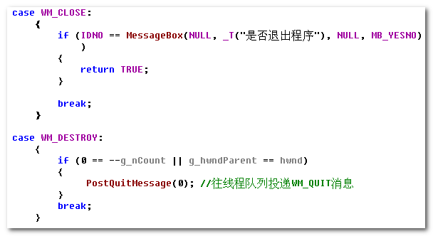

注意进程的结束。

鼠标消息
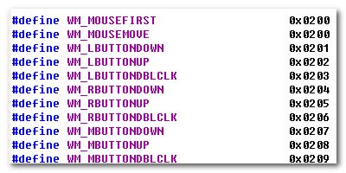
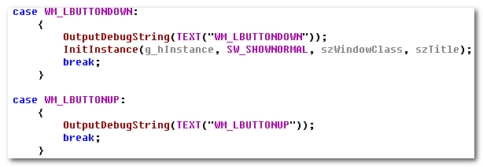

WM_COMMAND
这不是与鼠标消息、键盘消息等并列的，但是它所涉及的比较多，需要进行仔细处理。

The WM_COMMAND message is sent when the user selects a command item from a menu, when a control sends a notification message to its parent window, or when an accelerator keystroke is translated.

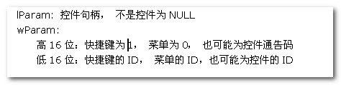
所以，它是菜单、控件、快捷键的处理入口。

3.1 Menu
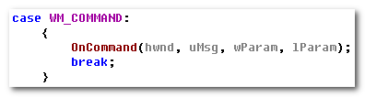
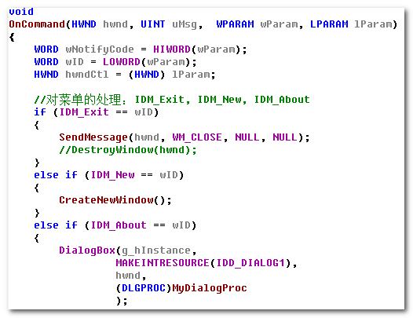

3.2 Dialog
特殊的，对于Dialog， （当然了，Dialog与它们并非等位）
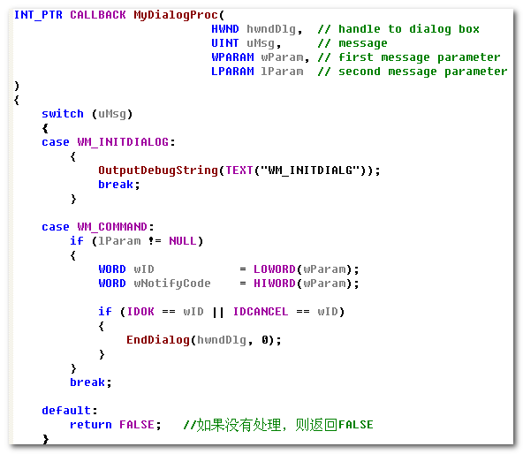

键盘消息
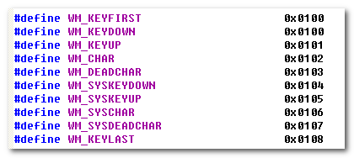
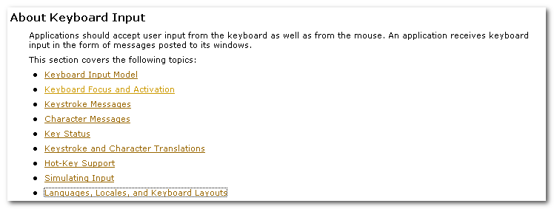
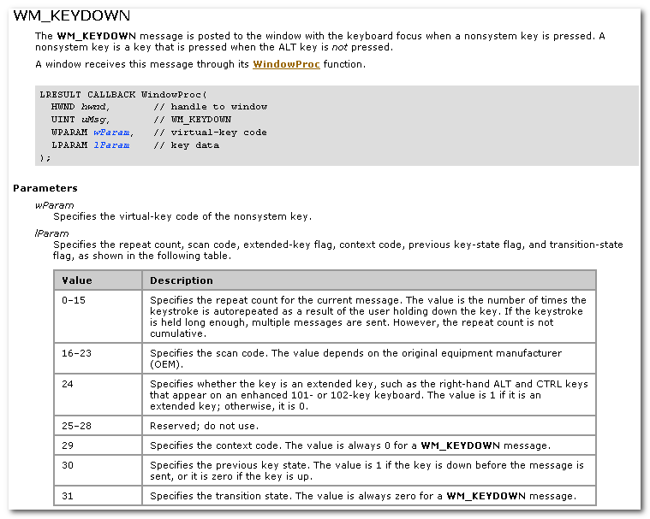

这里涉及：
- Nonsystem key : is a key that is pressed when the ALT key is not pressed.
- Virtual-key Code
- Scan Code

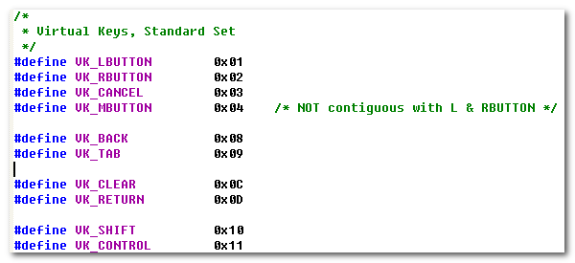
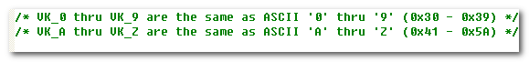
The keyboard device driver receives scan codes from the keyboard, which are sent to the keyboard layout where they are translated into messages and posted to the appropriate windows in your app.

Assigned to each key on a keyboard is a unique value called a scan code, a device-dependent identifier for the key on the keyboard.

The keyboard device driver interprets a scan code and translates(map) it to a virtual-key code, a device-independent value defined by the system that identifies the purpose of a key.

After translating a scan code, the keyboard layout creates a message that includes the scan code, the virtual-key code, and other info about the keystroke, and then places the message in the system message queue.
The system removes the message from the system message queue and posts it to the message queue of the appropriate thread. Eventually, the thread’s message loop removes the message and passes it to the appropriate window procedure for processing.
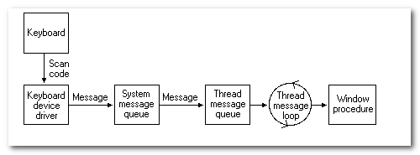

Pressing a key causes a WM_KEYDOWN or WM_SYSKEYDOWN message to be placed in the thread message queue attached to the window that has the keyboard focus.

WM_SYSKEYDOWN
The WM_SYSKEYDOWN message is posted to the window with the keyboard focus when the user presses the F10 key (which activates the menu bar)， or holds down the ALT key and then presses another key.
It also occurs when no window currently has the keyboard focus; in this case, the WM_SYSKEYDOWN message is sent to the active window.
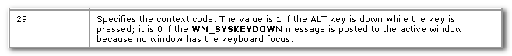

When the context code is zero, the message can be passed to the TranslateAccelerator function, which will handle it as though it were a normal key message instead of a character-key message. This allows accelerator keys to be used with the activate window even if the active window does not have the keyboard focus.

System and NonSystem Keystrokes
System keystrokes produces system keystroke message, WM_SYSTEMDOWN and WM_SYSTEMUP. Nonsystem keystrokes produce nonsystem keystroke messages, WM_KEYDOWN and WM_KEYUP.

If your window procedure must process a system keystroke message, make sure that after processing the message the procedure passes it to the DefWindowProc function. Otherwise, all system operations involving the ALT key will be disabled whenever the window has the keyboard focus. That is, the user won’t be able to access the window’s menus or System menu, or use the ALT + ESC or ALT + TAB key combination to activate a different window.

System keystroke messages are primarily for use by the system rather than by an app. The system uses them to provide its built-in keyboard interface to menus and to allow the user to control which window is active.

Nonsystem keystroke messages are for use by app windows. The DefWindowProc function does nothing with them. A window procedure can discard any nonsystem keystroke messages that it does not need.

A typical window procedure does not process keystroke messages from character keys. Instead, it uses the TranslateMessage function to convert the message into character message.

TranslateMessage function translates virtual-key messages into character messages. The character messages are posted to the calling thread’s message queue, to read the next time the thread calls the GetMessage or PeekMessage function.

Virtual-key messages && Character messages

If the message is translated(that is, a character message is posted to the thread’s message queue), then return value is nonzero.

If the message is WM_KEYDOWN, WM_KEYUP, WM_SYSKEYDOWN or WM_SYSTEMUP, the return value is nonzero, regardless of the translation.

TranslateMessage produces WM_CHAR messages only for keys that are mapped to ASCII characters by the keyboard driver.

If applications process virtual-key messages for some other purpose, they should not call TranslateMessage. For instance, an app should not call TranslateMessage if the TranslateAccelerator function returns a nonzero value.

If you app must obtain character input from the user, include the TranslateMessage function in the loop.

The TranslateAccelerator function processes accelerator keys for menu commands. The function translate a WM_KEYDOWN or WM_SYSKEYDOWN message to a WM_COMMAND or WM_SYSCOMMAND message and then sends the WM_COMMAND or WM_SYSCOMMAND message directly to the appropriate window procedure.

4.1 WM_KEYDOWN
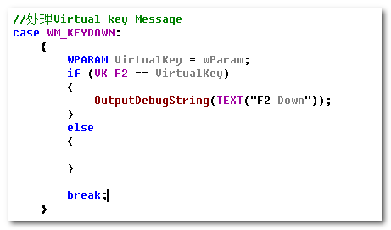

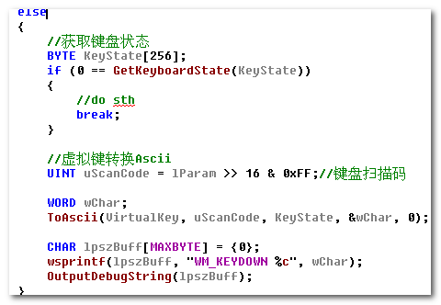

进行从Virtual-Key 到ASCII的转换。

4.2 WM_CHAR
在上面的WM_KEYDOWN中，我们手动的进行了Virtual-Key到ASCII的转换。
此外，还可以使用TranslateMessage进行.

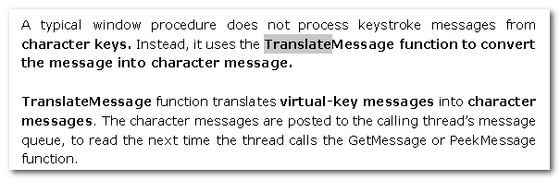
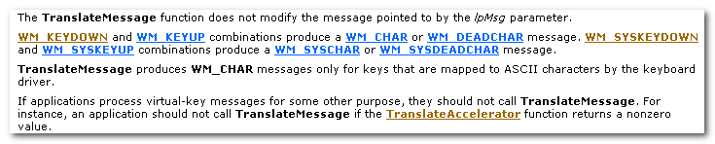
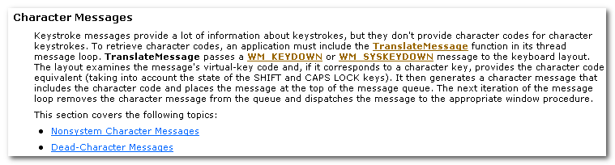

TranslateMessage passes a WM_KEYDOWN or WM_SYSKEYDOWN message to the keyboard layout. The layout examines the message’s virtual-key code and, if it coresponds to a character key, provides the character code equivalent. It then generates a character message that includes the character code and places the message at the top of the message queue. The next iteration of the message loop removes the character message from the queue and dispatches the message to the appropriate window procedure.

快捷键
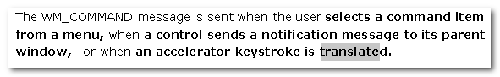
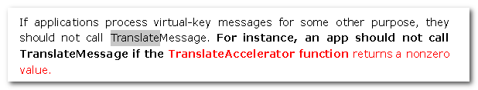
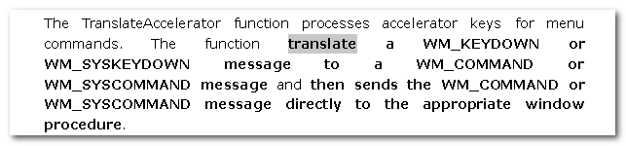

所以，这最终的处理，还是利用已经使用的WM_COMMAND或者WM_SYSCOMMAND.

When TranslateAccelerator returns a nonzero value and the message is translated, the application should not use the TranslateMessage function to process the message again.

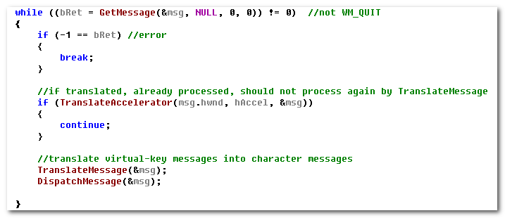
An accelerator need not correspond to a menu command.

If the accelerator command corresponds to a menu item, the app is sent WM_INITMENU and WM_INITMENUPOPUP message, as if the user were trying to display the menu. However, thz messages are not sent if any of the following conditions exist:
- The window is disabled.
- The accelerator key combination does not correspond to an item on the window menu and the window is minimized.
- A mouse capture is ineffect.

通告消息
在前面我们知道WM_COMMAND处理MENU, ACCELERATOR, CONTROL三类消息。
而其中，控件也是窗口的一种，它也有相应的消息处理。
- 对于一些系统已经预设的控件，它的消息处理也是系统所负责的。用户仅需按照相应的约定进行处理即可。
- 用户也可自定义消息， WM_USER + id

它们的共同点是：
子窗口获知自身状态的改变，需SendMessage or PostMessage 到父窗口，让父窗口来进行相应的处理。

这种子窗口向父窗口发送消息的机制，就是通告消息。同时，它也可以携带额外的信息。

后续，我们会了解到消息的反射。

6.1 ListBox
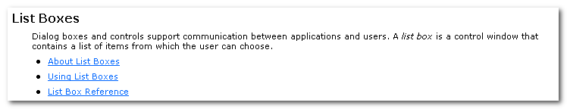
Dialog boxes and controls support communication between applications and users.
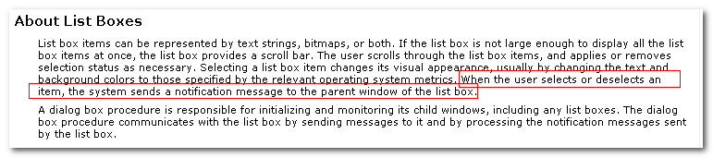
When the user selects or deselects an item, the system sends a notification message to the parent window of the list box.

A dialog box procedure is responsible for initializing and monitoring its child windows, including any list boxes. The dialog box procedure communicates with the list box by sending messages to it and by processing the notification messages sent by the list box.

List Box <-----------------------> Parent Dialog

6.1.1 初始化（父窗口发送给控件）
ListBox 作为DialogBox（或者其他窗口）的子窗口，我们要对其进行操作，首先要获取到其句柄。 这可通过其父句柄，利用GetDlgItem实现。
You can use the GetDlgItem function with any parent-child window pair, not just with dialog boxes. As long as the hDlg parameter specifies a parent window and the child window has a unique identifier, GetDlgItem returns a valid handle to the child window.

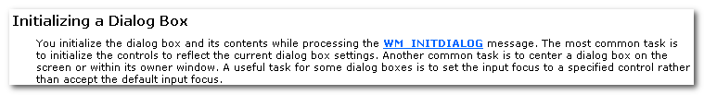
You Initialize the dialog box and its contents while processing the WM_INITDIALOG message. The most common task is to initialize the controls to reflect the current dialog box settings.

Another common task is to center a dialog box on the screen or within its owner window.

A useful task for some dialog boxes is to set the input focus to a specified control rather than accept the default input focus.

要知道，ListBox是作为系统预设的控件存在的，已经对消息处理进行了封装，我们要完成对其对操作，需要SendMessage 或者PostMessage。
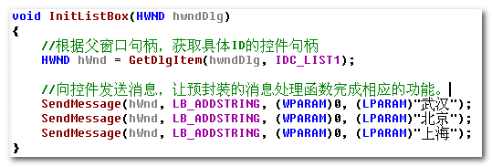
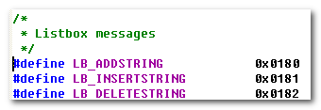
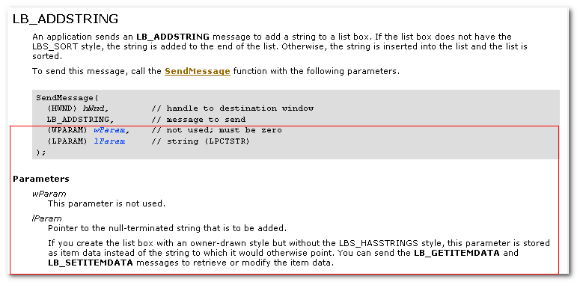
在利用SendMessage发送消息时，要特别注意wParam, lParam, 在不同的消息中，它们的含义、要求不同。

这样，系统就负责完成了ListBox的操作

6.1.2父窗口的消息处理（父窗口处理来自控件的通告消息）
The dialog box procedure communicates with the list box by sending messages to it and by processing the notification messages sent by the list box.

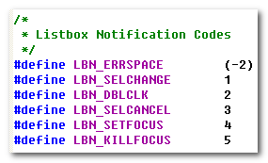
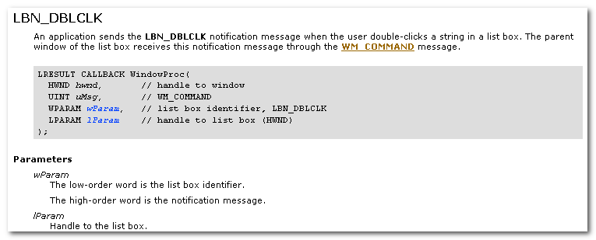
An application sends the LBN_DBLCLK notification message when the user double-click a string in a list box. The parent window of the list box receives this notification message through the WM_COMMAND message.

这里，我们看到List Box的Notification message 是通过WM_COMMAND来进行传递的。

而在下面的一个案例中（List-View control)中，其消息是通过WM_NOTIFY进行传递的。
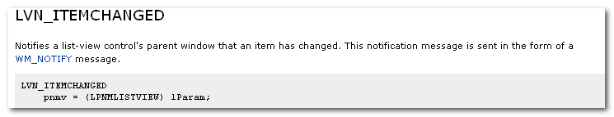

那么，为啥是通过不同的方式呢？
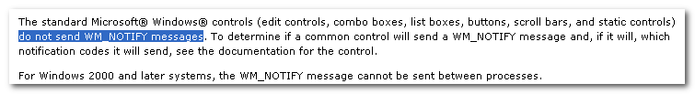
也就是说，控件消息的传递方式，是由具体的控件实现所设定的，没有明确的准则。
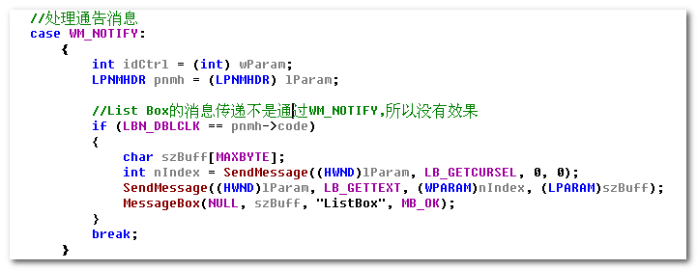

6.2 List-View Control
具体的处理，可参看相应的MSDN。其处理流程与List Box类似，但是相应的差别，如消息类型，消息传递机制（WM_NOTIFY)
